Water/Electricity/Sewarage NOC
old house
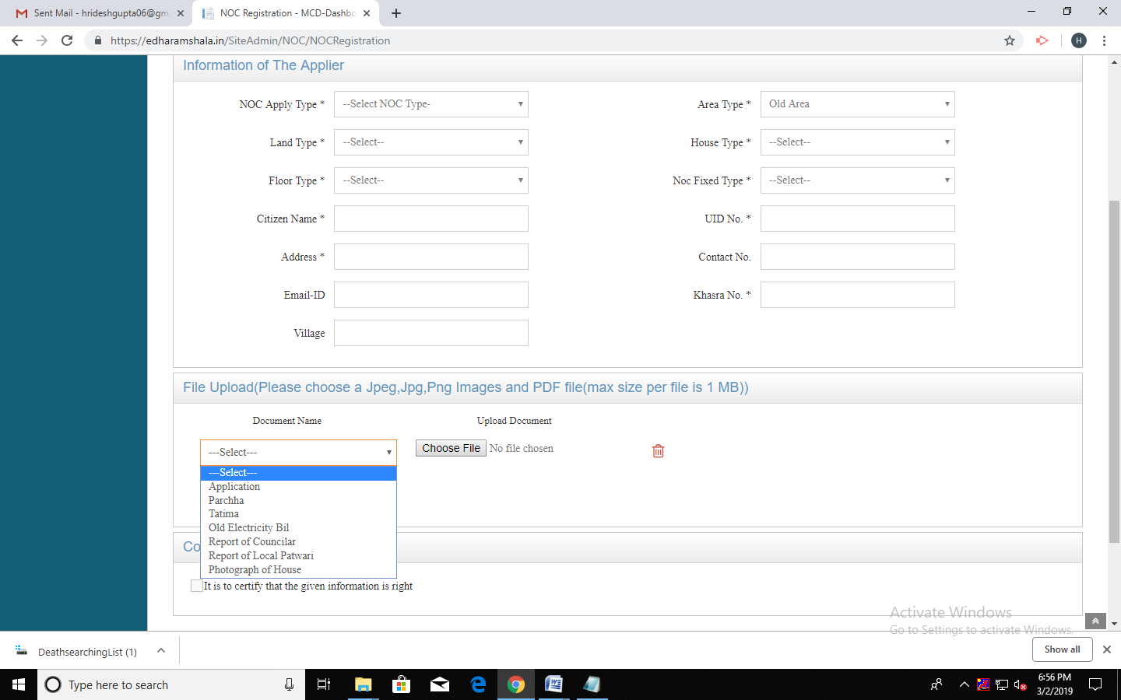
Application
Parcha
Tatima
Report of Councilar
Report of local patwari
old Electricity Bill
Photograph of House
Affidavid if requard

New House
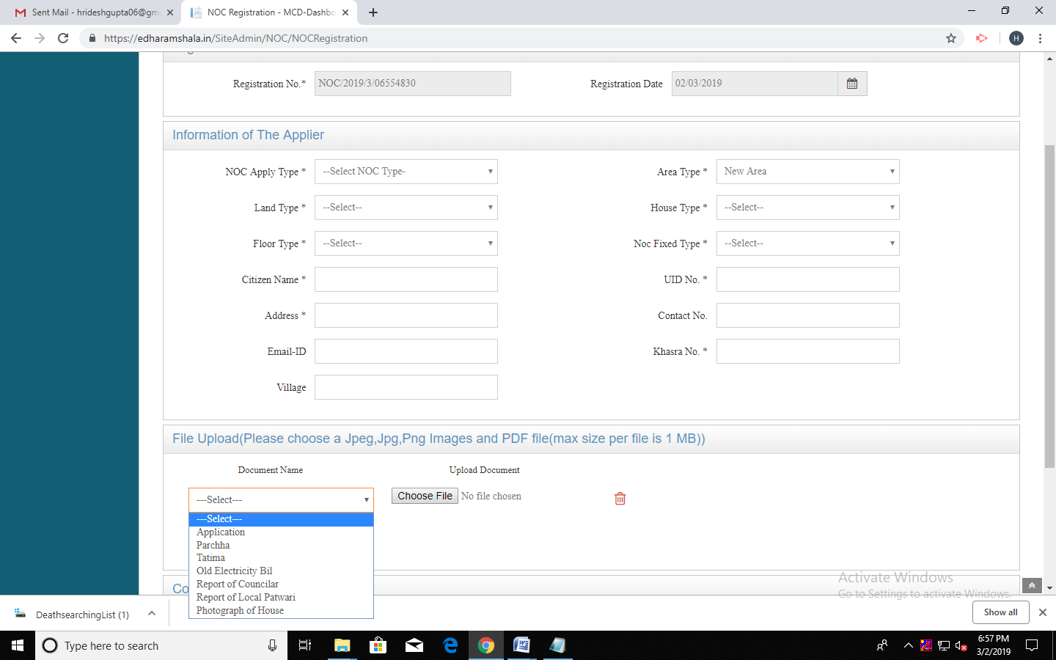
Application
Map Approval
Photograoh of house

